Lab 1 – INFO 3104

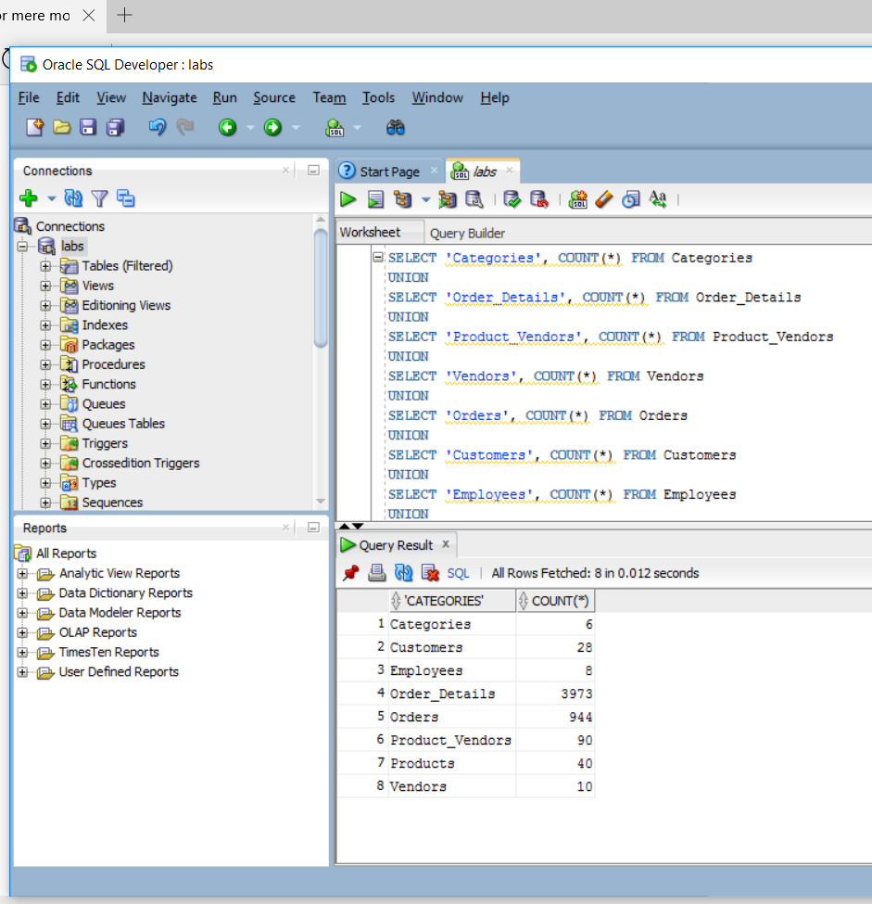

1: composite identifier

2: foreign key

3: result set of a stored query

4: with a junction table.